After clicking “Start Practice” in Module 1.2, a prompt saying “what can you help me with today” is automatically submitted in the conversation. It needs to be the screen with no prompt,so the user has to enter a prompt to start the conversation.
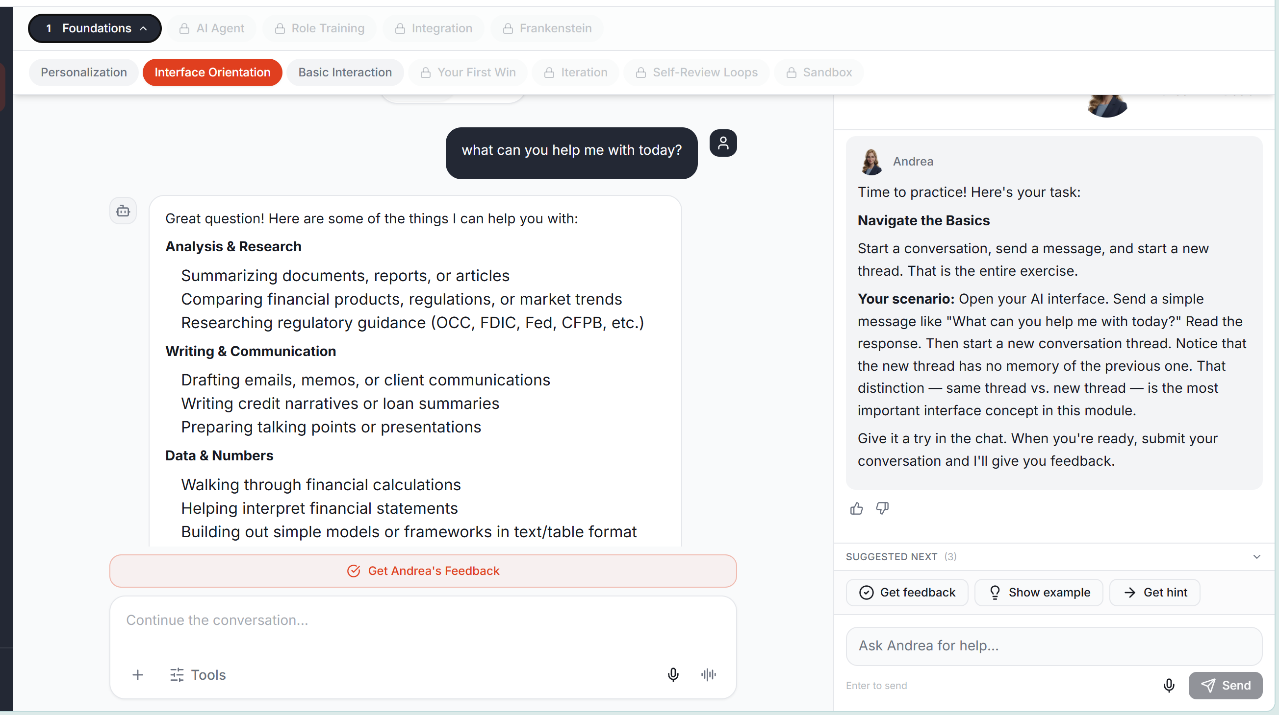
In Module 1.3, the plus button should allow the user to add a file or attachment. When erringing the Practice, a small pop up should highlight the + and describe that an attachment can be added here, or the user can drop their information directly in the chat.
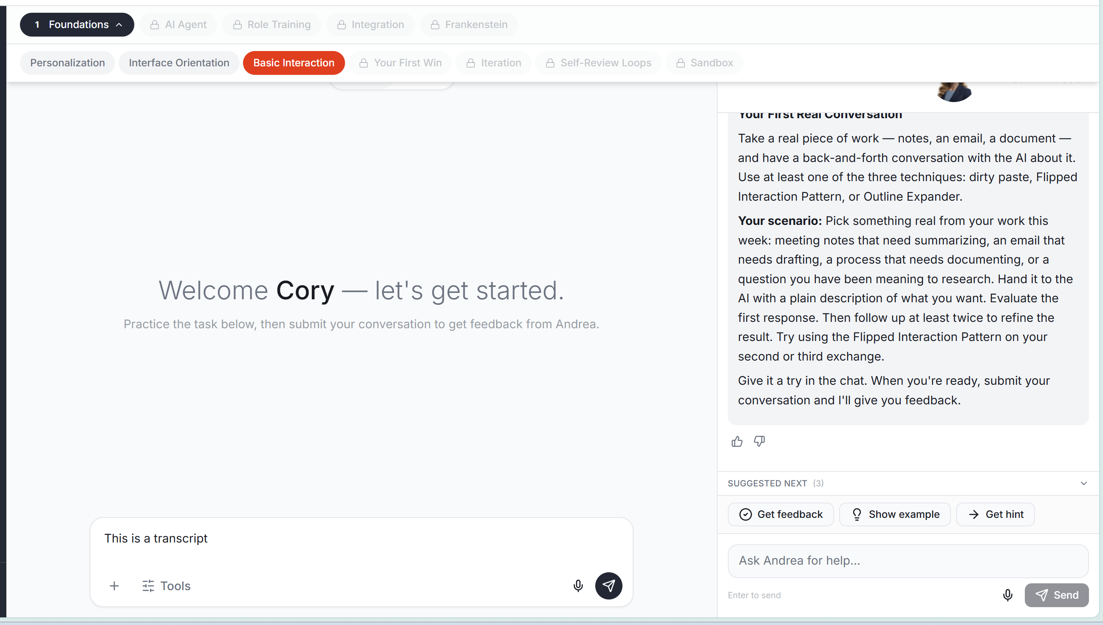
At some point in the training that makes the most sense, I’d like to be able to describe how Shift + Enter allows the user to add a row in their prompt without submitting the prompt to AI.
----------------------------------------
When I tab out of a page, it still pauses andrea and refreshes the page.
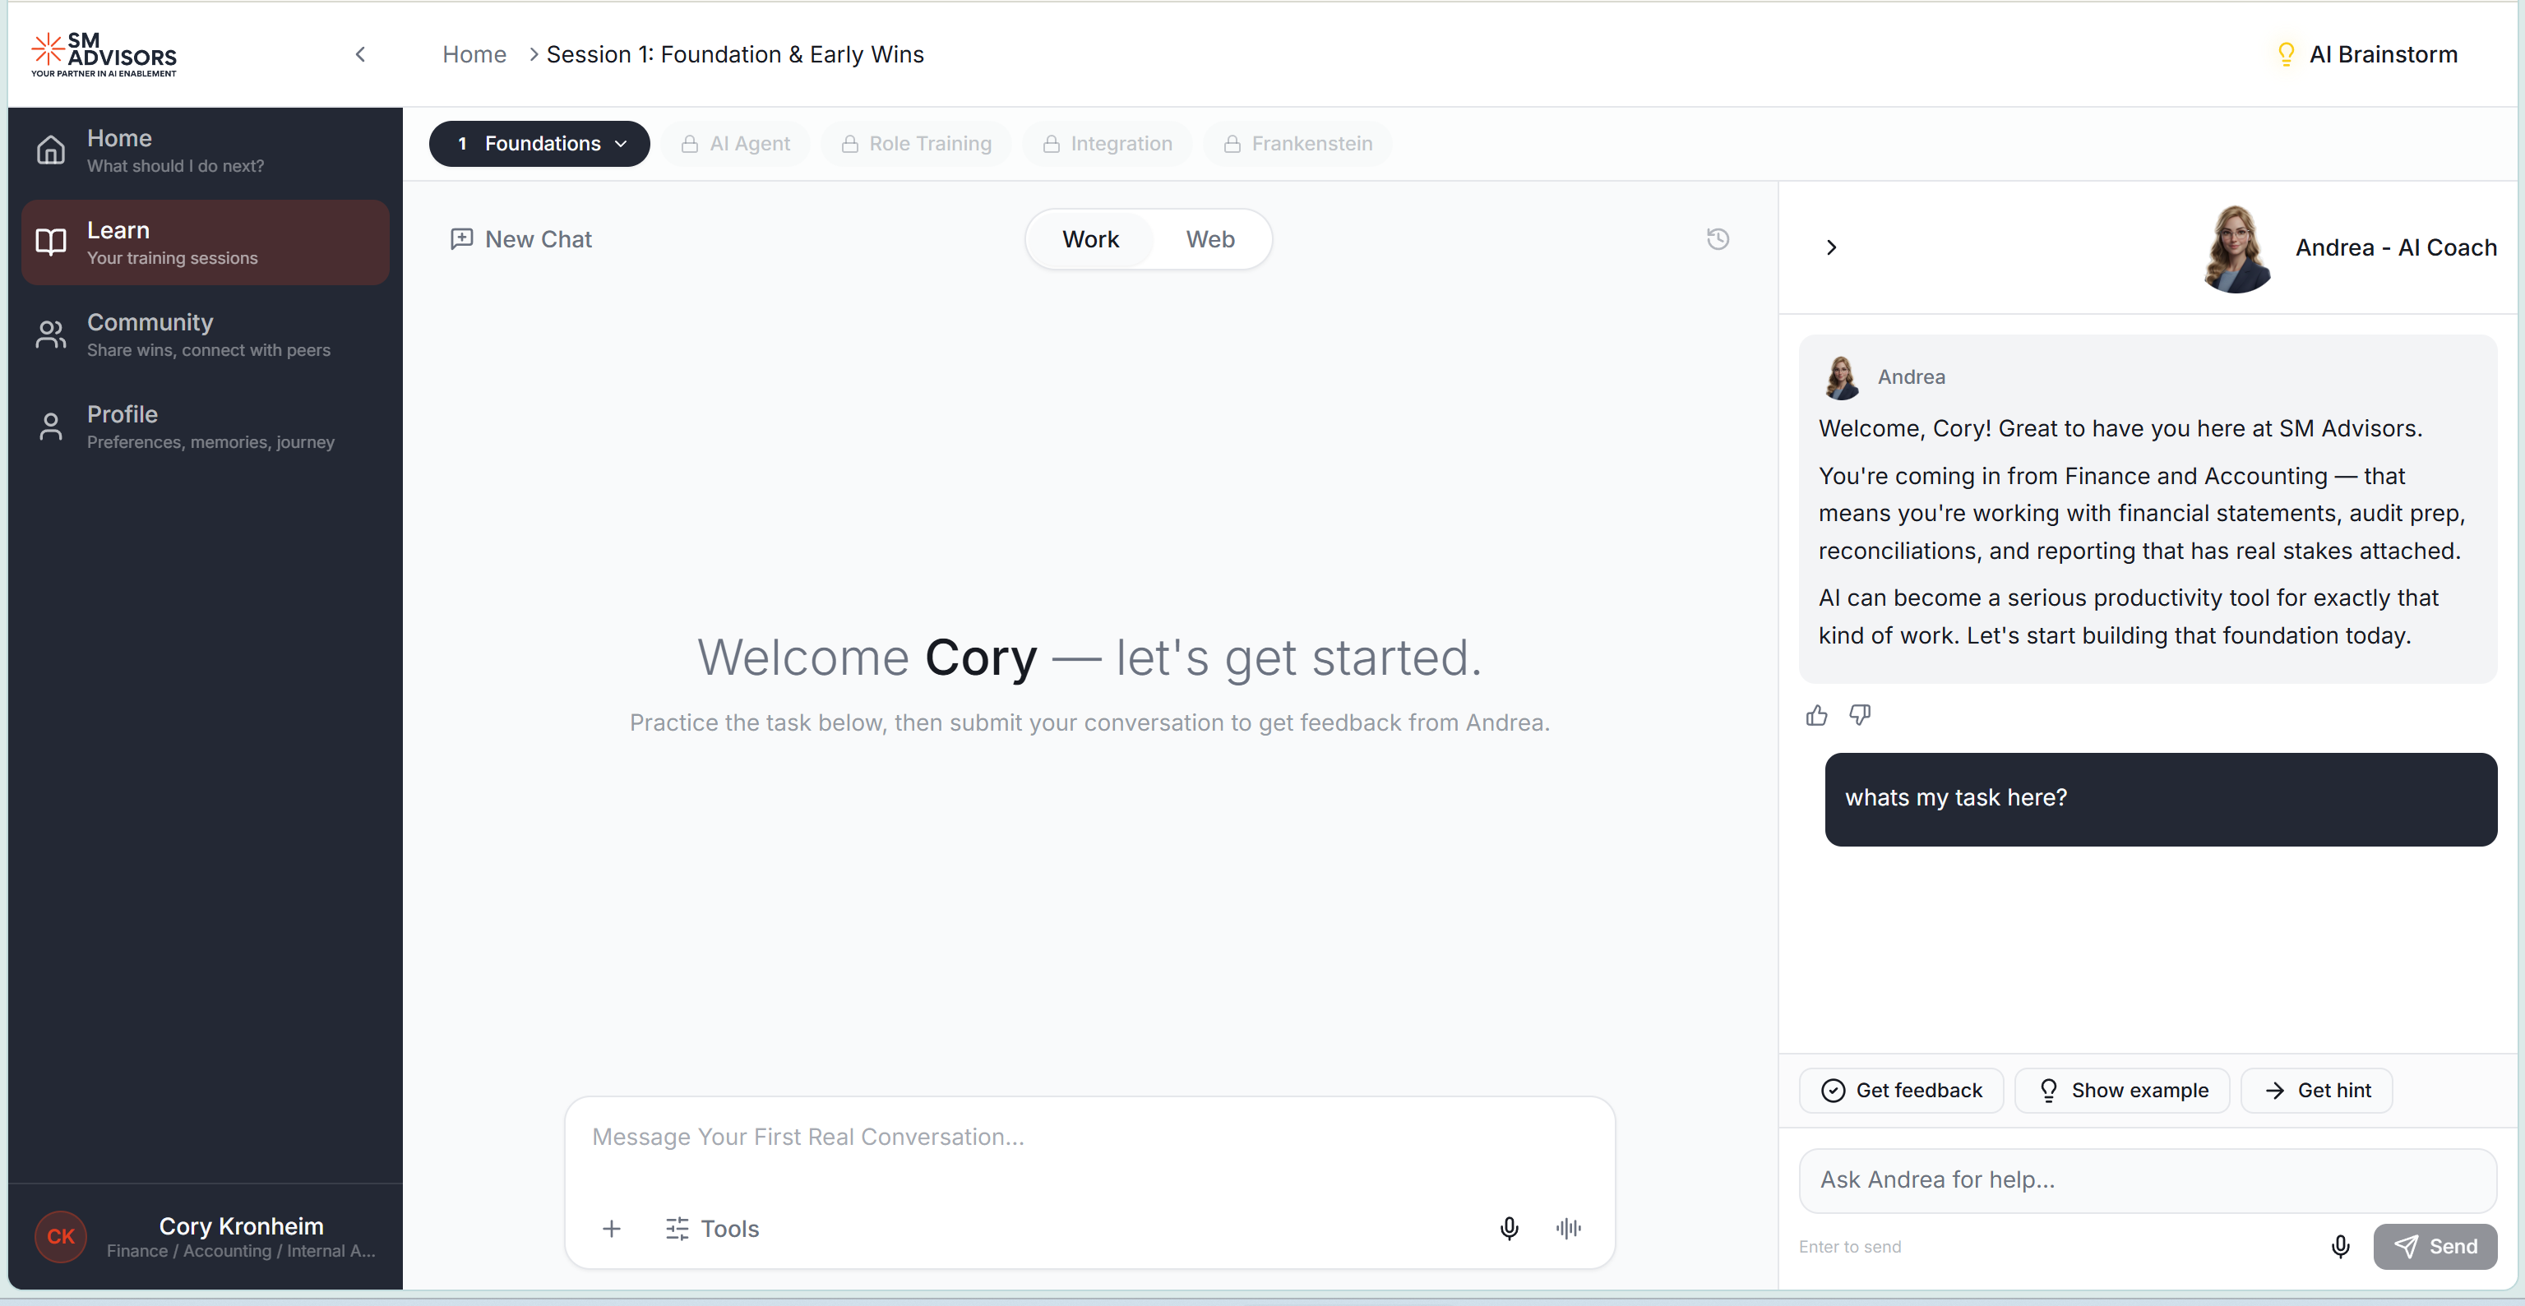
In module 1.3, The Almost There prompt isn’t clear enough to let a user know whats necessary to change to pass and get to the next module. Also, Try Again creates a new conversation. It should allow the user to continue in the same conversation.
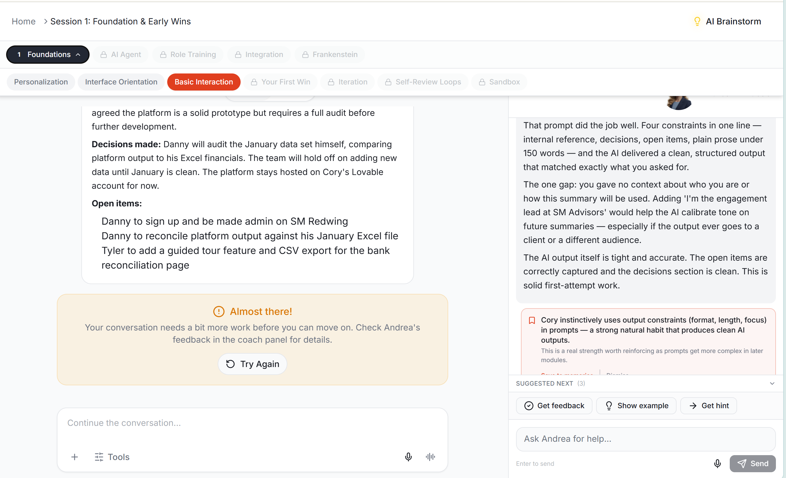
When recording using the microphone, can the transcript of the recording be displayed as the user speaks? That way they can see that the recording is working
